Troubleshoot Unrecognized Activity on Your Ad Account

21,326 views

Do you think your personal Facebook profile may have been hacked? Learn how to [secure your account](https://www.facebook.com/help/203305893040179).

If you don't recognize activity on your advertising account, try to learn more about the charges and the possible causes. Here are a few steps:

* View your payment history.
* See if you reached your payment threshold or monthly bill date.
* Check your daily budget or lifetime budget.
* Check for other spenders on your account.

View your payment history

The [Billing section](https://www.facebook.com/ads/manage/billing.php) is where you can find the billing information of your ad account. There, you can [view your payment history](https://www.facebook.com/help/156558524411792) and get receipts for payments you've made for your ads.

To learn more about a specific charge, go to the list of transactions in the Billing section. Then, click the **Transaction ID** of the charge you want to know more about. These steps bring you to your receipt for that charge. Your ads receipt shows the information like how much you paid, when you paid, which payment method was charged and which ads you spent money on.

See if you reached your payment threshold or monthly bill date

Once you have your ads receipt, you can review the **Billing Reason** that's listed on it to find out why you were charged. It lets you know if a charge happened because you reached your [payment threshold or monthly bill date](https://www.facebook.com/help/105373712886516).

Remember that it's normal to be charged for ads multiple times a month or even after you've stopped running them. This is because when you create ads on Facebook (like boosting posts from your Page), you don't pay for them right away. Instead, as they run and people see them, they accrue ad costs that you're charged for later.

There are 2 ways you're charged for these costs:

* Whenever your ad costs reach your payment threshold
* On your monthly bill date

A [payment threshold](https://www.facebook.com/help/105373712886516) is an amount that you can spend on ads before we charge you for them. Whenever your ad costs reach your payment threshold, we charge you that amount. Your monthly bill date is when we charge you each month for ad costs that don't quite reach your payment threshold.

So, you may be charged multiple times or just once in a given month, depending on how much money you're spending on ads:

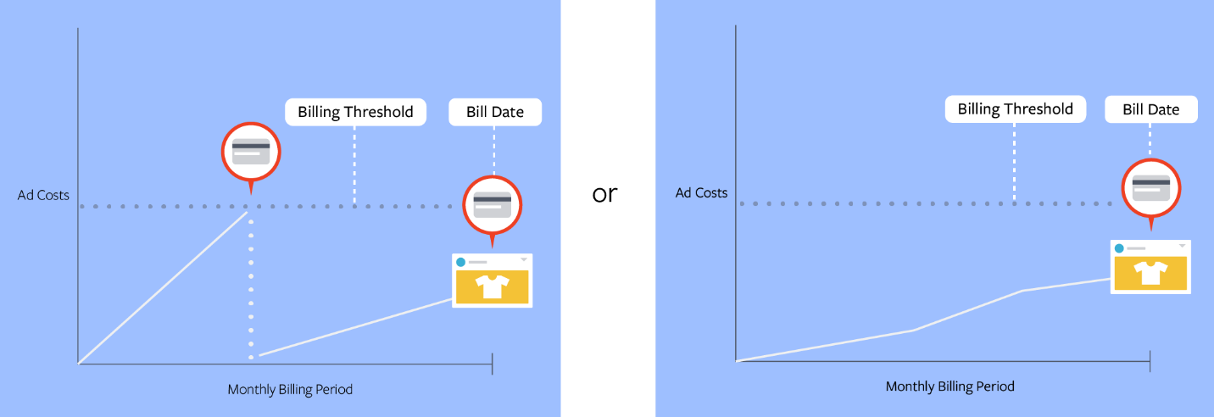

Check your daily budget or lifetime budget

A budget is a cost control tool. It helps control your overall spend for an ad set (or campaign). There are 2 types of budgets:

* [**Daily budget**](https://www.facebook.com/help/206296442738865): The average amount you're willing to spend on a specific ad set or campaign every day. If you have more than one active ad set in your account, remember that each ad set has a separate budget.
* [**Lifetime budget**](https://www.facebook.com/help/340985466050775): The amount you're willing to spend over the entire run-time of your ad set or campaign. Our system automatically tries to evenly spread the amount you spend across the period that you've selected.

If you set a daily budget but meant to set a lifetime budget (or the other way around), you may be billed differently than expected.

**Note:**If you want to spend a specific amount over the lifetime of your ad, make sure that you select the **Lifetime Budget**, not **Daily Budget**.

Check for other spenders on your account

If you share your payment method or ad account with others, check with them when you don't recognize charges on your account. It's likely that another person has run separate ads using your payment method or ad account.

In that case, go to your [Account Settings](https://www.facebook.com/ads/manager/account/settings/). In the **Ad Account Roles** section, you can see who has access to your account. Contact anyone you know who may have placed an order for ads with your payment method.

You can also [review your account history](https://www.facebook.com/ads/manage/history) to see recent activity on your ad account.

Need more help?

After trying these steps, if you still see purchases that you don't recognize and/or believe that someone has hacked your ad account, please [let us know](https://www.facebook.com/micro_site/url/?click_from_context_menu=true&country=PH&destination=https%3A%2F%2Fwww.facebook.com%2Fhelp%2Fcontact%2F649167531904667%3Fref%3D32&event_type=click&last_nav_impression_id=0UeIhdmoUoZhd7fG4&max_percent_page_viewed=79&max_viewport_height_px=789&max_viewport_width_px=1600&orig_http_referrer=https%3A%2F%2Fwww.messenger.com%2F&orig_request_uri=https%3A%2F%2Fwww.facebook.com%2Fbusiness%2Fhelp%2F524424920973484&primary_cmsid=524424920973484&primary_content_locale=en_US&region=apac&scrolled=true&session_id=1aYIALjjBodzIGYfj&site=fb4b&extra_data%5bview_type%5d=v3_initial_view&extra_data%5bsite_section%5d=help&extra_data%5bplacement%5d=%2Fbusiness%2Fhelp%2F524424920973484).